**Container Scaling with Docker Swarm.**

**docker service create -p 8080:8080 --name bootcamp jocatalin/kubernetes-bootcamp:v1**

**docker service ls**

**docker service ps bootcamp**

**curl localhost:8080**

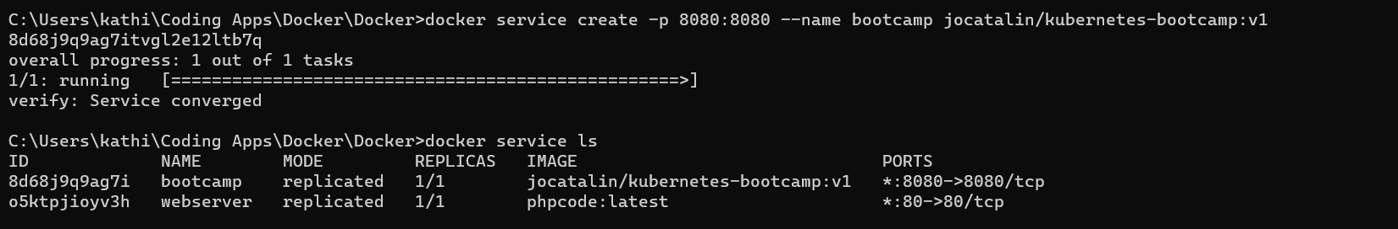

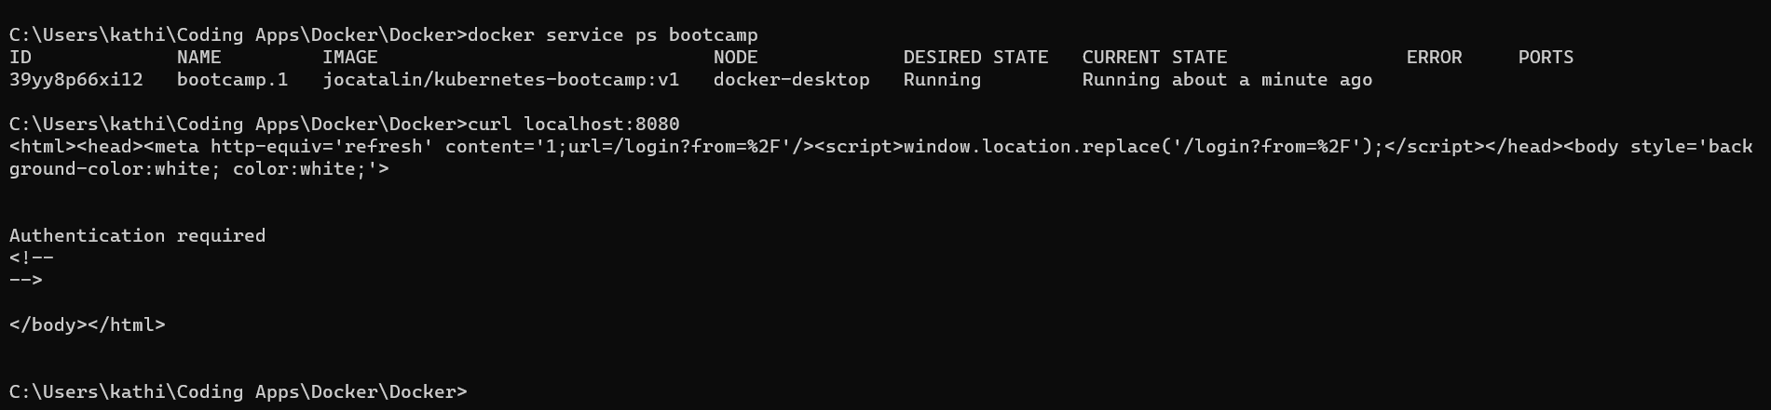

**docker service scale bootcamp=3**

**docker service ps bootcamp**

**curl localhost:8080**

